

Travlr Getaways

CS 465 Project Software Design Document
Version 3.0

Table of Contents

CS 465 Project Software Design Document 1
Table of Contents 2
Document Revision History 2
Instructions 2
Executive Summary 3
Design Constraints 3
System Architecture View 3
Component Diagram 3
Sequence Diagram 4
Class Diagram 4
API Endpoints 4
The User Interface 4

Document Revision History

Version | Date | Author | Comments
1.0 | 05/22/2026 | Brianna Peno | Milestone One – first draft
2.0 | 6/7/2026 | Brianna Peno | Milestone Two – second draft
3.0 | 6/20/2026 | Brianna Peno | Final Project

Instructions

Fill in all bracketed information on page one (the cover page), in the Document Revision History table, and below each header. Under each header, remove the bracketed prompt and write your own paragraph response covering the indicated information.

Executive Summary

The Travlr Getaways web application will use a full stack architecture built with the MEAN stack, which includes MongoDB, Express.js, Angular, and Node.js. This architecture supports both the customer-facing website and the administrator single-page application (SPA) while allowing all parts of the system to communicate with the database and server. Using the MEAN stack also allows the application to use JavaScript throughout the entire development process, which helps simplify maintenance and scalability as the application grows. The customer-facing side of the application allows users to browse travel packages, view trip details, and easily navigate the website through an intuitive interface. Its primary focus is delivering travel information efficiently while maintaining accessibility across devices. The front end communicates with the server through routes and APIs to retrieve trip data stored in the MongoDB database. The administrator SPA is designed separately from the customer-facing website and allows authorized administrators to manage travel package data without reloading entire pages. The SPA architecture improves performance and creates a faster and more interactive experience for administrators when adding, editing, or deleting trip information. The administrator side communicates with the same backend server and database, ensuring that updates made through the SPA are immediately reflected on the customer-facing website. This architecture creates a scalable and maintainable solution that supports both customer interaction and administrative management within a single integrated system.

Design Constraints

The development of the Travlr Getaways web application includes several design constraints that affect the application. One major constraint is the use of the MEAN stack. While this creates consistency by allowing JavaScript to be used throughout the project, it also limits development decisions to technologies and frameworks that integrate properly within the MEAN architecture. Another design constraint is the requirement to support both a customer-facing website and an administrator single-page application (SPA). The system must maintain secure separation between public user access and administrative functionality. This requires authentication, protected routes, and additional backend logic to ensure that only authorized administrators can modify travel package information. These security requirements increase the complexity of development and testing. The use of a NoSQL database such as MongoDB also introduces design considerations. MongoDB provides flexibility when storing travel package data, but developers must carefully organize collections and document structures to maintain consistency and avoid disorganized data. Unlike relational databases, there are fewer built-in relationships between data sets, which can require additional planning in application logic. Finally, time and maintainability constraints affect development decisions. The application must remain readable, modular, and easy to update in the future. Using MVC architecture, reusable Handlebars templates, JSON data structures, and Angular components help improve maintainability, but it also requires developers to follow consistent organizational standards throughout the project. These constraints ultimately shape how the application is designed, tested, secured, and expanded over time.

System Architecture View

Component Diagram

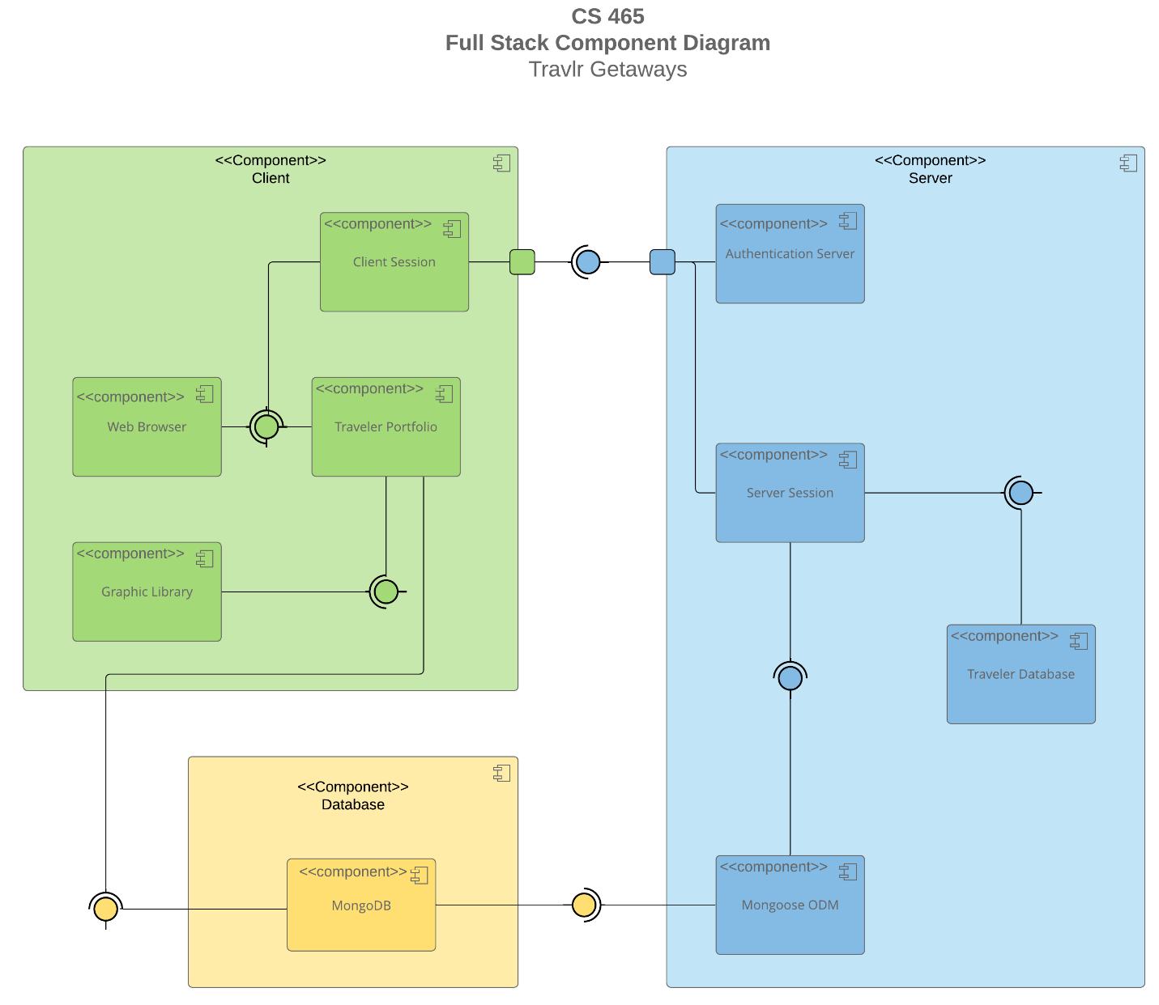

A text version of the component diagram is available: CS 465 Full Stack Component Diagram Text Version.

The overall system architecture of the Travlr Getaways web application follows a component-based full stack design. Based on the component diagram provided in the SDD, the system is organized into three major sections: the client components, the server components, and the database component. This architecture supports scalability, maintainability, and communication between the frontend user interface, backend application logic, and database storage.
The client layer contains the Web Browser, Client Session, Traveler Portfolio, and Graphic Library components. The Web Browser is responsible for displaying the application to users and interacting with both the Traveler Portfolio and Client Session components. The Traveler Portfolio component manages the customer-facing travel content and interacts with the Graphic Library to display images throughout the website. These components work together to provide users with an interactive browsing experience.
The server layer contains the Authentication Server, Server Session, Traveler Database, and Mongoose ODM components. The Authentication Server manages user authentication and validates administrative access to the system. The Server Session component manages communication between the client-side application and backend services while maintaining active user sessions. The Traveler Database component stores and retrieves travel package information used throughout the application. The Mongoose ODM component acts as a bridge between the Node.js application and the MongoDB database, allowing the application to interact with database records using JavaScript objects.
The database layer contains the MongoDB component, which serves as the primary NoSQL database for the application. MongoDB stores trip data, user information, and other application content in JSON-like documents. The database communicates with the Mongoose ODM component to support efficient data retrieval and updates between the server and database layers.
The relationships between these components demonstrate how information flows throughout the application. The client-side components communicate with the server session components to request and display travel data. The server components process requests, authenticate users, and retrieve or update data through Mongoose ODM and MongoDB. This layered architecture allows the customer-facing website and the administrator single-page application (SPA) to function together.

Sequence Diagram

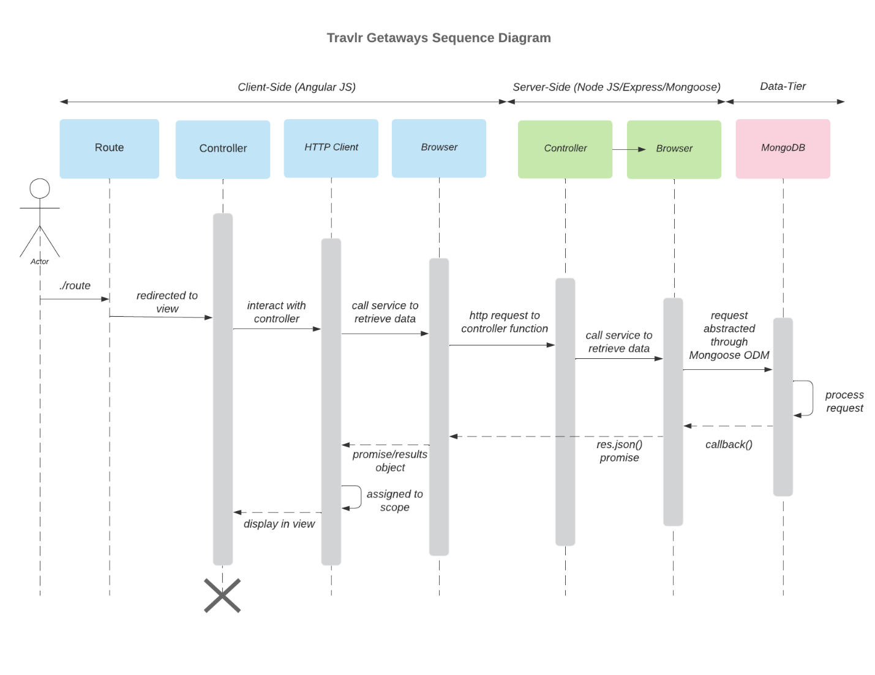

The application follows a 3-tier structure where the client side, server side, and data tier all work together to handle user actions. When a user navigates the site, Angular routes send them to the correct view and connect it to a controller. From there, the controller uses an HTTP service to send requests to the server, such as for sign in, viewing trips, or admin functions. Once the request reaches the server, an Express controller processes it and handles tasks such as validating a login, retrieving trip data, or checking admin permissions. That service then uses Mongoose to communicate with MongoDB, where the actual data is stored. During sign in, the user submits credentials through the Angular controller, which sends them to the server. The server checks the database for a matching user and returns either success or failure. For trips, the client requests trip data, the server pulls it from MongoDB, and Angular displays it in the view once it receives the response. Admin actions follow the same flow but with added permission checks before any create, update, or delete operations are made. Overall, data constantly moves back and forth between the client, server, and database, with each layer handling its specific role before sending results back to the browser for display.

Class Diagram

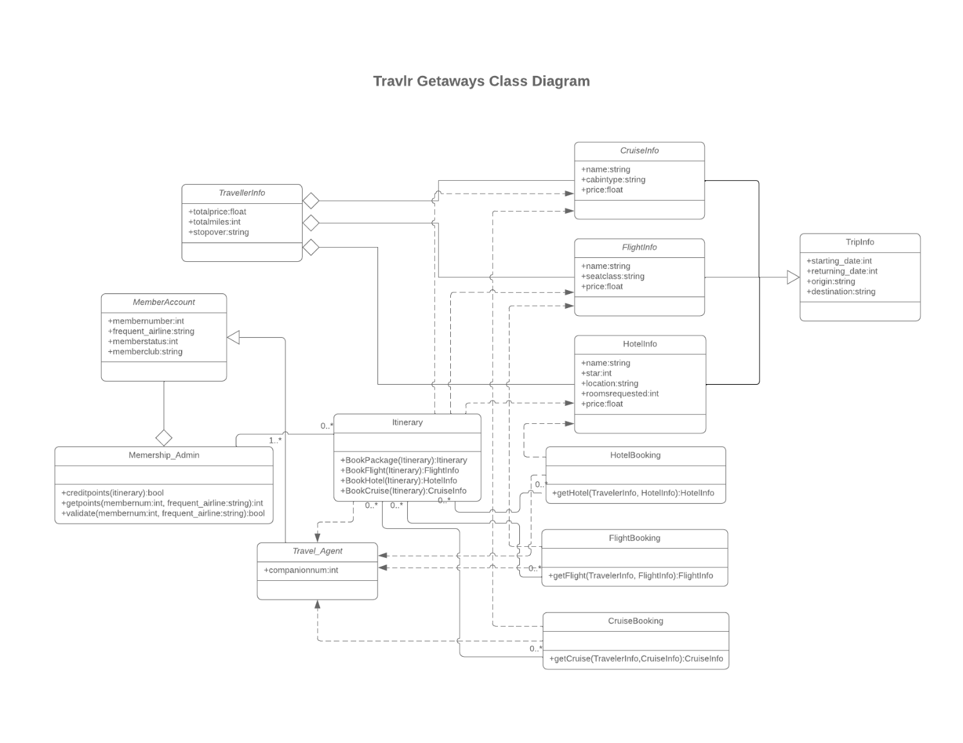

The class diagram shows how the JavaScript classes work together to manage travel bookings within the Travlr Getaways application. The TravelerInfo class stores traveler details such as the number of travelers, total miles, and stopover information. This class is associated with the Itinerary class, which acts as the central class for creating travel packages. The Itinerary class contains methods for booking flights, hotels, cruises, or complete travel packages.
The application uses separate classes for each travel option. FlightInfo, HotelInfo, and CruiseInfo store details about available flights, hotels, and cruises, including names, pricing, and other travel-specific information. These classes are connected to the TripInfo class, which contains trip details such as departure date, return date, origin, and destination. To support reservations, the application includes FlightBooking, HotelBooking, and CruiseBooking classes that retrieve booking information based on traveler and trip selections.
The diagram also includes membership functionality. The MemberAccount class stores membership information such as membership number, airline affiliation, membership status, and club membership. The Membership_Admin class manages membership features by validating memberships and awarding points. Finally, the Travel_Agent class represents travel agents who can assist with itinerary and booking operations. Together, these classes separate responsibilities across the application, making it easier to manage traveler information, bookings, memberships, and trip details.

API Endpoints

Method | Purpose | URL | Notes
GET | Retrieve all trips | /api/trips | Returns all trip records from MongoDB as JSON
GET | Retrieve single trip | /api/trips/:tripCode | Returns a single trip identified by the trip code
POST | Create a new trip | /api/trips | Create a new trip record
PUT | Update existing trip | /api/trips/:tripCode | Update specific trip
POST | Register a new user | /api/register | create new user account
POST | Authenticate a user | /api/login | Validate user credentials and returns a JSON Web Token used to access protected endpoints

The User Interface
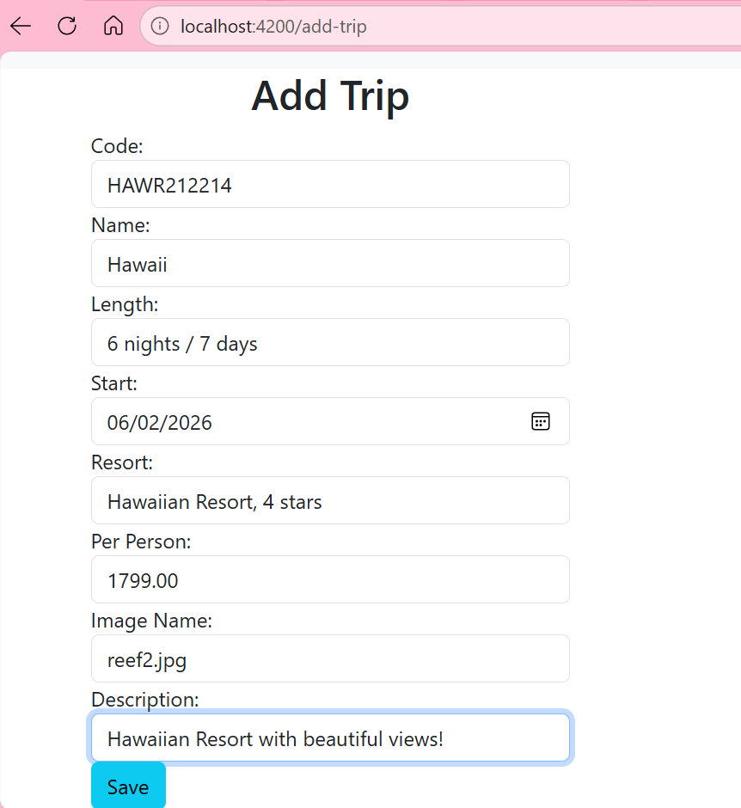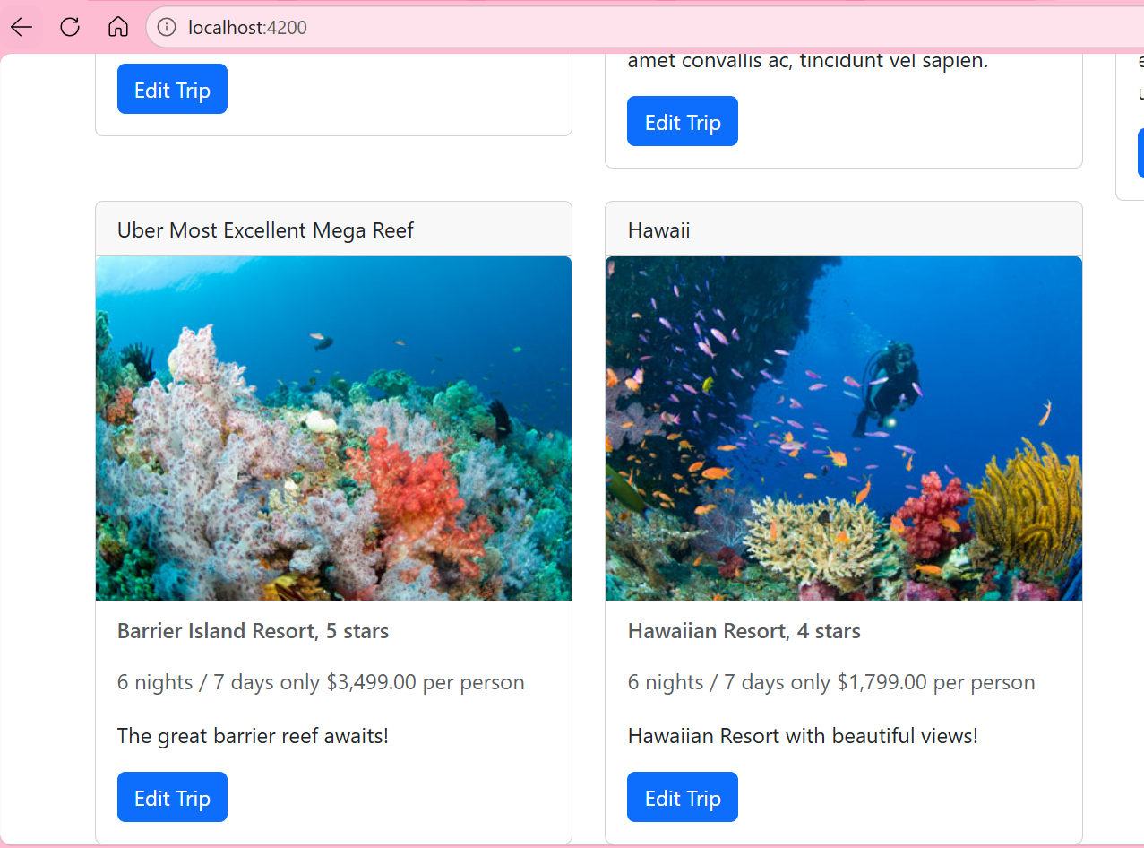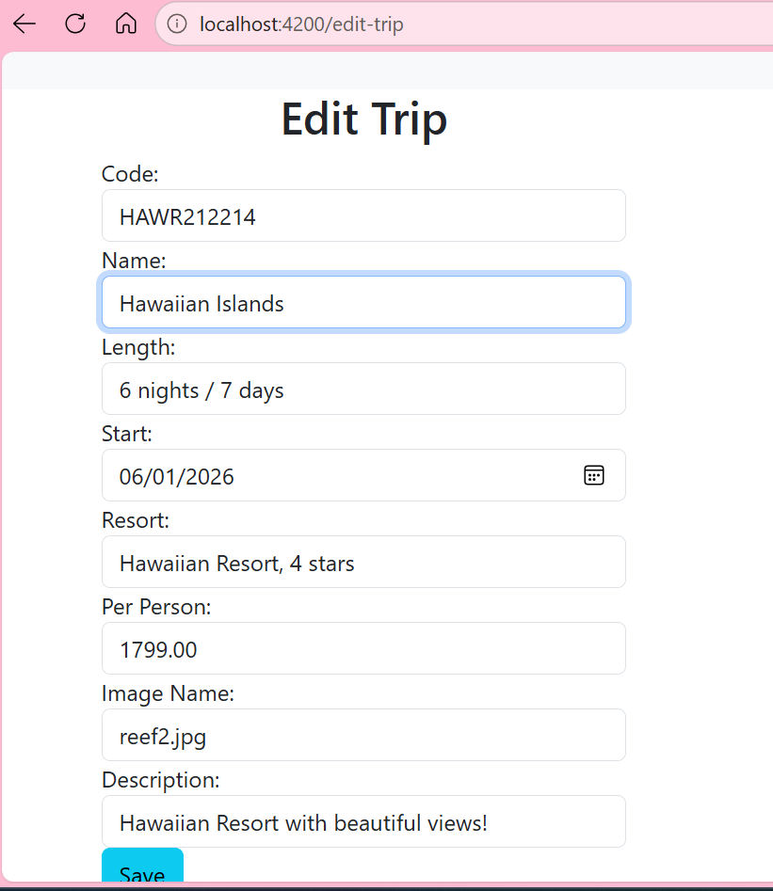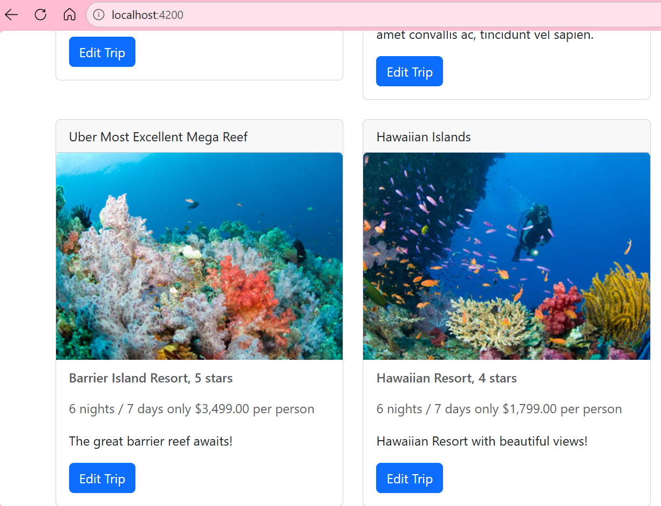

The Angular project structure is different from the Express HTML customer-facing application. The customer-facing site uses Express, Handlebars templates, routes, controllers, and server-side rendering. When a user requests a page, the server generates the HTML and sends it to the browser. In contrast, the Angular administration site is a client-side single-page application (SPA) built using components, services, routing, and TypeScript. Instead of generating new pages on the server, Angular updates the content within a single page and communicates with the backend API to retrieve or modify data. The Angular project is organized around reusable components and services, while the Express application is organized around routes, controllers, views, and database access. This separation makes the Angular application more modular and easier to maintain as functionality grows.
One advantage of SPA functionality is that it provides a smoother user experience because the page does not need to fully reload every time data changes. The application can retrieve data from the API and update only the necessary portions of the screen. This creates a faster and more responsive interface. Another advantage is the ability to create reusable components, such as the Trip Card component used throughout the administration site. However, SPAs are also more complex to develop and debug. During this project, I found that even small errors in routing, component templates, or service calls could prevent data from displaying correctly. This caused some headache and time wasting, but I was able to work through it. Compared to a traditional web application, the SPA provides more interactive functionality, supports reusable UI elements, and allows direct communication with the REST API for creating, retrieving, and updating records without refreshing the page.
Testing the SPA required verifying that Angular was successfully communicating with the API and that the API was correctly interacting with the MongoDB database. I used Postman to test GET, POST, and PUT requests independently before testing them through the Angular interface. Once the API endpoints were verified, I used the Angular application to retrieve trip data and display it in reusable Trip Card components. Some of the errors I encountered included 404 Not Found responses caused by incorrect routes, validation errors when required fields such as description were missing, template syntax errors involving mismatched HTML tags, and connection issues when the Express server was not running. I also experienced situations where the Angular application successfully retrieved data but failed to render components because of template or routing issues. Troubleshooting these problems reinforced the importance of testing each layer of the application separately before testing the full integration.
One question I still have involves best practices for debugging larger Angular applications. As the application grows, it becomes more difficult to determine whether an issue originates in the component, service, routing configuration, API endpoint, or database layer. I would also like to learn more about state management and how larger Angular applications maintain and share data efficiently between components. While this project provided a strong introduction to SPA development, I would like more experience designing larger applications and implementing more advanced Angular features in future projects.

